CMPE202 – Java2UMLParser – Report

Xiaoyu Zhou (011491038)

**Part I – Class Diagram**

Introduction

Source Code

Execution Screenshot

Testing & Generated Diagram Pictures

uml-parser-test-1: generated graph:

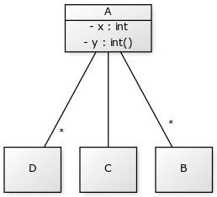

uml-parser-test-2: generated graph:

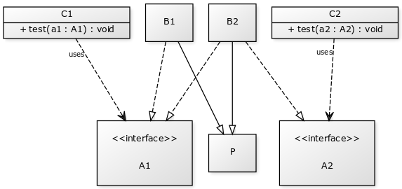

uml-parser-test-3: generated graph:

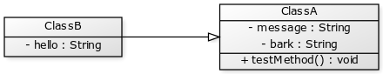

uml-parser-test-4: generated graph:

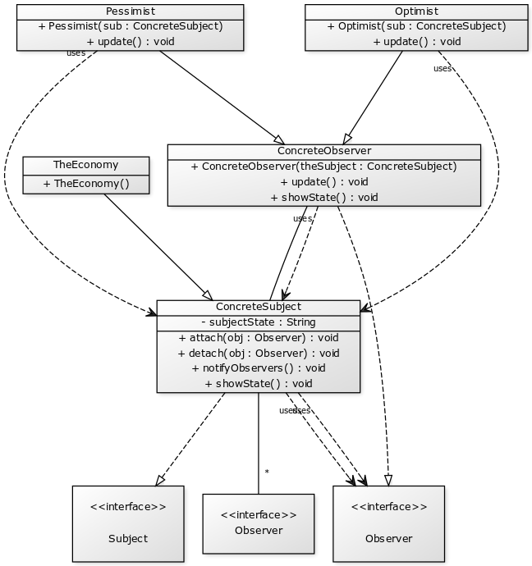

uml-parser-test-5: generated graph:

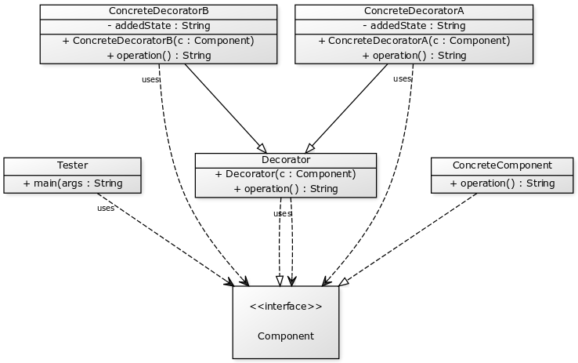

**Part II – Sequence Diagram**

Introduction

Source Code

Execution Screenshot

Testing & Generated Diagram Pictures